Published 1st July 2016

Enterprise Mode Site List Manager

Self Service Portal

Deployment Guide

*Yammer:*

*Topic Tag*

*Key Contacts:*

**Summary**: This document describes the deployment of Enterprise Mode Site List Manager tool.

Contents

1. Overview 1

2. EMIE Self Service Portal 1

3. Required Hardware 1

4. Required Software 1

5. Creating AppPool and EMIE Web Site in IIS 1

6. Create and prepare database 1

7. ApplicationPoolIdentity to a SQL Server Login 1

8. Restart the ApplicationPool and Web Site 1

9. Registering first user 1

10. Register Scheduler Service (Used for Production EMIE List changes) 1

# Overview

Enterprise Mode is a compatibility mode that runs applications on IE, letting websites render using a modified browser configuration, avoiding the common compatibility problems associated with them. Also, any website that is not compatible with Microsoft Edge, can be redirected and rendered in IE using the best browser configuration.

The objective of this portal is to govern the process of EMIE Site List Management so as to maintain site list accuracy, and ensure necessary checks, approvals to be acquired, before any changes are made. The automated push to production will help avoid human errors.

Many organizations identify web app compatibility as a significant cost to upgrading because web apps need to be tested and upgraded before adopting a new browser. The improved compatibility provided by Enterprise Mode can help give organizations confidence to upgrade to the latest version of IE. In particular, IE11 lets customers benefit from modern web standards, increased performance, improved security, and better reliability.

# EMIE Self Service Portal

The EMIE Self Service Portal is a web based application built on MVC framework with Angular JS with SQL Server as a backend database.

# Required Hardware

This scenario requires the following hardware or hardware features for successful completion:

|  |  |
| --- | --- |
| Hardware | Description |
| Minimum Physical Memory | 16 GB RAM recommended |
| Available disk space | The PC must have at least 8GB of free space. Disk must be formatted by NTFS file system for better security |

# Required Software

This scenario requires the following software or software features for successful completion:

|  |  |
| --- | --- |
| Software | Minimum Version |
| Client Operating System | Windows 7 or higher |
| Active Directory | Domain joined |
| Additional Server Infrastructure | Internet Information Service (IIS) 6.0 or later |
| SQL Server | Microsoft SQL Server Enterprise Edition 2012 or later |

# Creating AppPool and EMIE Web Site in IIS

### Copy the deployment folder to web server

1. Copy the deployment directory to local drive of the web server from **<TBD>**

### Create a new application pool

1. In [IIS Manager](https://www.microsoft.com/technet/prodtechnol/WindowsServer2003/Library/IIS/b0c14479-83e3-435d-a935-819fe396e7d2.mspx), expand the local computer, right-click **Application Pools**, and then click **Add** **Application Pool**.

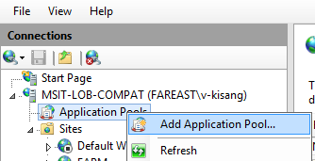

1. In the **Application pool name** box, type the name of the new application pool **e.g.** **EMIEWebAppPool**.
2. Select the **.Net CLR** version **v4.0** or later and select **Managed Pipeline Mode** as **Integrated.**
3. Click **OK.**

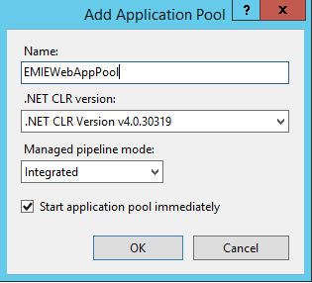

1. Now select the AppPool ‘**EMIEWebAppPool**’ from the list and click on ‘**Advanced Settings**’ option from left pane.
2. Confirm the ‘**Identity’** property is set to **’ApplicationPoolIdentity’,** click **OK** andclose the dialogue**.**

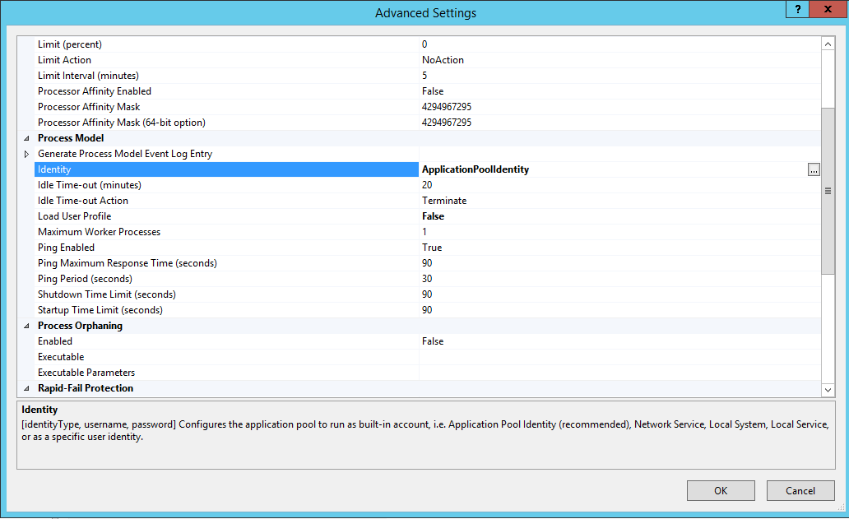

1. Now navigate to Deployment Directory e.g. D:\EMIEWebApp.
2. Right click on the directory, from Properties dialogue security tab and add ‘**IIS AppPool\EMIEWebApp**’ with ‘**Full Control**’ permission and ‘**Everyone’** with‘**Read & Execute**’ permission.

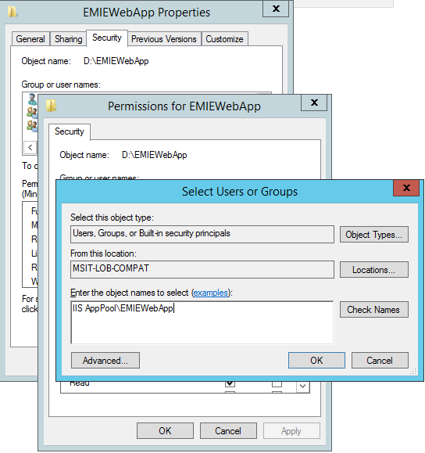

### Create a EMIE-SSP Web Site

1. In IIS Manager, expand the local computer, and right-click the **Sites** folder.
2. Select **Add** **Web Site..**. The Web Site Creation Wizard appears.

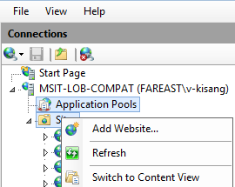

1. In the **Site Name** box, type a ‘**EMIEWebPortal’** for the site.
2. Now select the Application Pool we created earlier ‘**EMIEWebAppPool**’ by clicking on the ‘**Select’** button.
3. In the **Path** box, type the name of the directory or click **Browse** to navigate to the directory that contains the site deployment directory.
4. Select the Binding type, IP Address and Port as appropriate. (You can seek help from your network administrator configuring this.)
5. Uncheck the check box **‘Start the Website immediately’**
6. Click **Ok**.

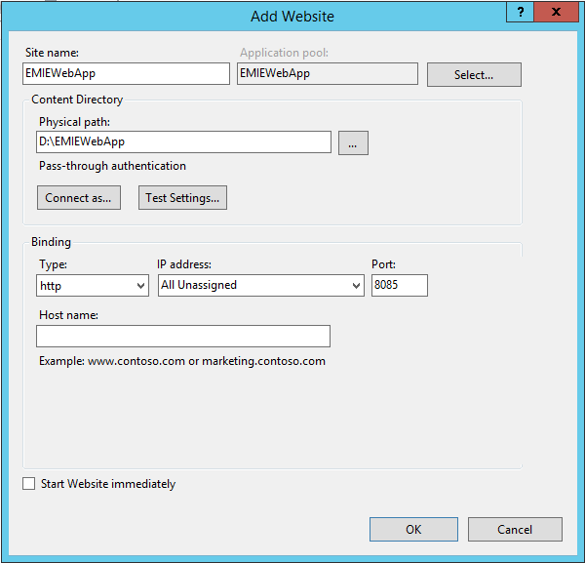

1. Now again from IIS Manager, expand the local computer and select the website created ‘**EMIEWebApp**’ and from ‘**Features View**’ double click the ‘**Authentication**’ icon.
2. ‘Anonymous Authentication’ will be by default enabled, also enable the ‘**Windows Authentication**’ for this site from context menu.

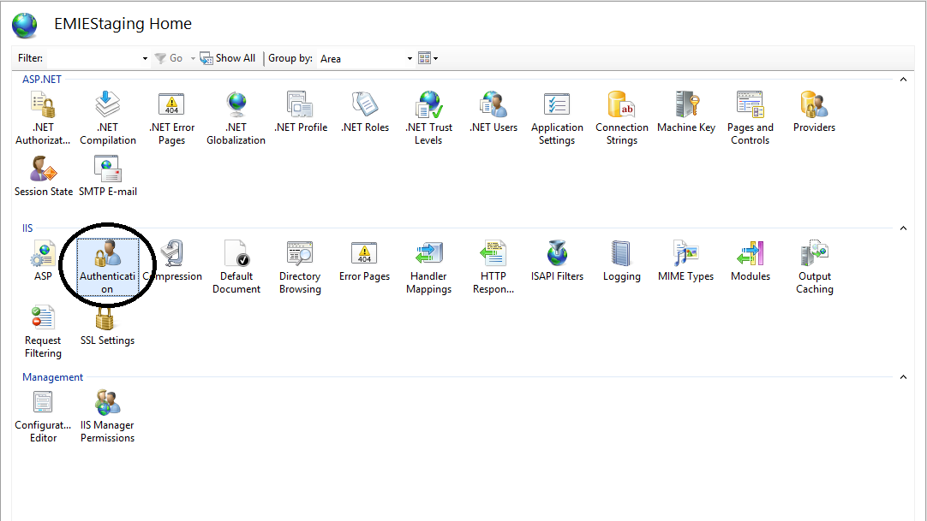

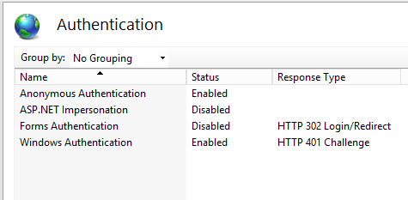

1. Now double click on the **‘Connection String’** icon, and open the ‘**LoBMergedEntities**’, put your database name against **‘initial catalog’** field. (Section 6. Describes on how to create the database)

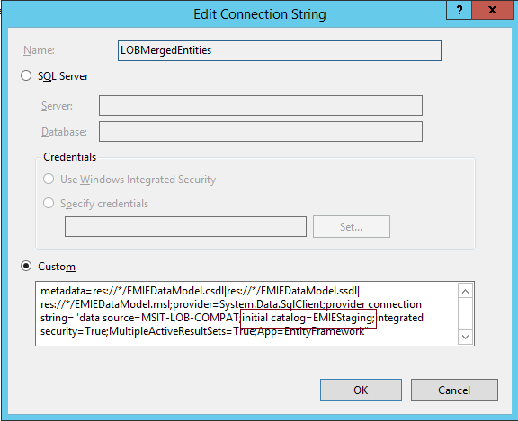

# Create and prepare database

1. Launch SQL Server Management studio.
2. In Object Explorer, connect to an instance of the SQL Server Database Engine and then expand that instance.
3. Right-click **Databases**, and then click **New Database**.

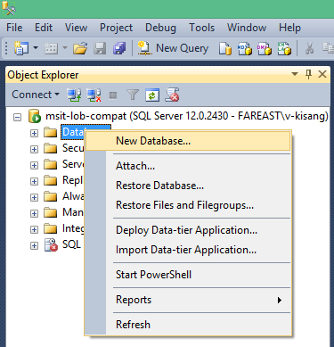

1. In **New Database**, enter a database name.
2. Create the database by accepting all default values by clicking OK.
3. Now, open **‘CreateEMIETables.sql’** query, replace database name placeholder with the database name you created in earlier step in ‘**Use <DatabaseName Placeholder>’** andexecutethe query.

# ApplicationPoolIdentity to a SQL Server Login

For a local SQL Server (where IIS and SQL are on same server)

* Open SQL Server Management Studio (SSMS) and connect to the SQL Server.
* Open the Security folder at the server level and not the security folder for the database.
* Right click on the logins and select New Login.

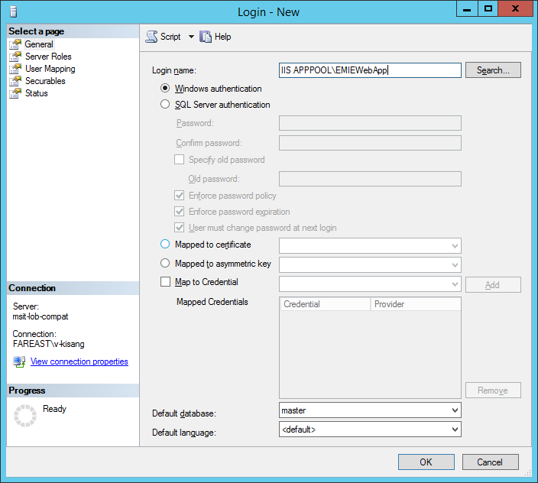

* For the login, type **IIS APPPOOL\<AppPoolName>** **(IIS AppPool\EMIEWebAppPool)** and **DO NOT CLICK SEARCH** and select **OK** (If a search is executed, it will resolve to an account with ServerName\AppPool Name and SQL will be unable to resolve the account’s SID since it is virtual)
* Next, select the **User Mapping** page, select and check **database** you created. From roles select the role as **db_owner.**
* Keep rest of the settings to defaults for the account and select **OK** to close dialog.

For a remote SQL Server (where IIS and SQL are on same server)

* Open **SQL Server Management Studio** (SSMS) and connect to the SQL Server.
* Open the **Security** folder at the server level and not the security folder for the database.
* Right click on the **logins** and select **New Login**.
* For the login, type **Domain\ServerName$** and **DO NOT CLICK SEARCH**
* Next, select the **User Mapping** page, select and check **database** you created. From roles select the role as **db_owner.**
* Select **OK**
* Select the defaults for the account and select **OK** to close dialog

# Restart the ApplicationPool and Web Site

* 1. In IIS Manager, expand the local computer, and select **Web Site** you created, click on **Restart** fromleft pane option.
  2. In IIS Manager, expand the local computer, and select **ApplicationPool** you created, click on **Restart** fromleft pane option.

# Registering first user

1. Open the browser and type the URL for EMIE Site. E.g. <http://lobcompat:85>
2. Log-in page will be displayed.

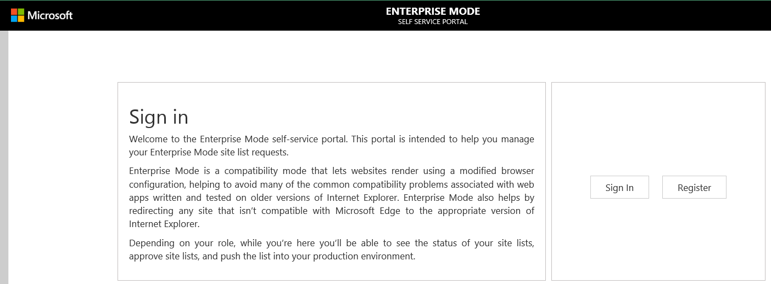

1. Click on ‘**Register**’ button to get registered to EMIE Portal.
2. In **‘User Email’** text box, type your name, a drop down will be displayed with all matching names with the text you entered.
3. Select your name from the dropdown.
4. Select ‘**Role’** as **‘EMIE Champion’** and click **‘Save’** button.

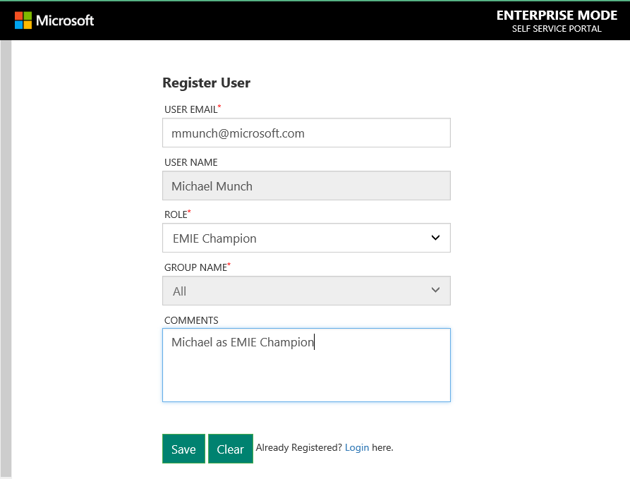

1. After completing the registration, we need to activate the user.
2. In new browser tab open the admin console by typing the URL http://<domain name>/#/EMIEAdminConsole (e.g. <http://lobcompat:9001/#/EMIEAdminConsole>)
3. It’ll ask for Master Username and Password. The default Username is **‘EMIEAdmin’** and password is set to **‘Admin123’.** It’s recommended that you change the password using ‘**Change Password’** link on your first use.



1. Select your user name and click ‘Activate’
2. Now, navigate to log in page and you should be able to log in to the portal.

# Configure SMTP Server and Port for Email Notification

1. Open **web.config** from the deployment folder in Visual Studio or an XML editor.
2. Update SMTP server and Port shown below. The email account and password can be set from EMIE application’s settings menu.

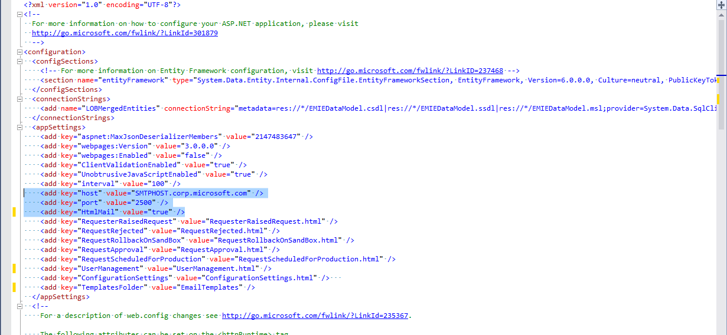

# Register Scheduler Service (Used for Production EMIE List changes)

1. Run **Visual Studio Development** command prompt as **Administrator**
2. Change directory to the path of **Installutil.exe** e.g. cd "C:\Windows\Microsoft.NET\Framework\v4.0.30319\"
3. Copy App_Data, bin and Logs folder of Service to server at any location.
4. Run command **Installutil** **"<service exe>**". e.g. **Installutil "C:/EMIE/EMIEWebPortal.SchedulerService.exe"**
5. It will ask for credential, give required credentials to run the service, success message should be displayed on prompt.
6. Open the services console using **Services.msc**, start the service with name **'EMIEScheduler'.**

END of Document